 

4th February, 2021

SALARY CERTIFICATE

This is to certify that Mr. Muhammad Umar Salman is working directly under my supervision as a Research Assistant at College of Business and Economics, United Arab Emirates University, Al Ain, UAE. However, he will be working remotely from Pakistan for the entire duration. His total remuneration is AED 1,800 (one thousand eight hundred) per month, and he has been working at this position since 5th October 2020.

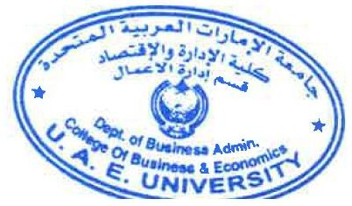This certificate is issued on the specific request of the employee. Sincerely,

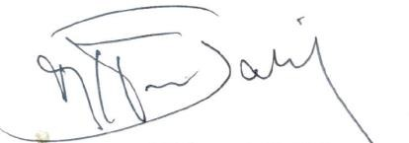

Muhammad Naiman Jalil, PhD. College of Business and Economics,

United Arab Emirates University (UAEU)

P.O. Box. 15551

Al Ain, United Arab Emirates Ph.: +971 3 713 5363

Email: [muhammad.jalil@uaeu.ac.ae](mailto:muhammad.jalil@uaeu.ac.ae)

**Business Administration Department**

PO BOX 15551, Al Ain, UAE T +971 3 713 5231

[cbe.busach@uaeu.ac.ae,](mailto:cbe.busach@uaeu.ac.ae) [www.cbe.uaeu.ac.ae/busa](http://www.cbe.uaeu.ac.ae/busa)

**قسـم إدارة األعمـــال**

ص.ب 15551، العـين، اإلمارات العربية المتحدة

+971 3 7135231 تـ

[cbe.busach@uaeu.ac.ae,](mailto:cbe.busach@uaeu.ac.ae) [www.](http://www/) cbe. uaeu.ac.ae/busa